Algorithm for restoring 3D coordinates of the bot from projections on x-ray images

Position of the bot in a 3D animal-associated coordinate system can be recovered from 2 X-Rays images obtained in non-parallel planes (the best if the angle between projections is 90 deg, but it is possible to work with images obtained in planes at a much smaller angle).

Assumptions of the method:

1. Beam divergence of X-Rays is negligible,
2. Animal image has no perspective distortions,
3. At least 4 fiducials are clearly seen on each of 2 projections,
4. Coordinates of fiducials are known in the animal-associated coordinate system

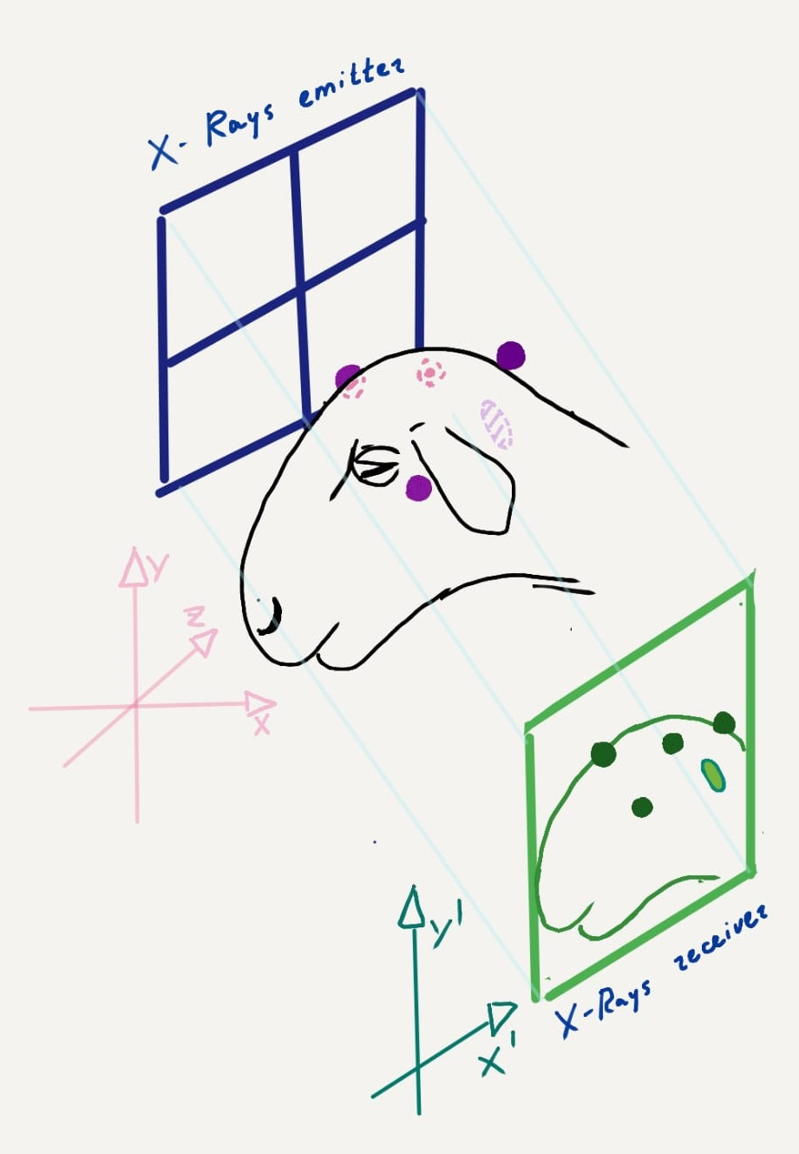

Fig.1. Scheme of X-Rays imaging (1 projection)

Here the X-Y-Z coordinate system is associated with the animal and fiducial coordinates in this system are obtained during the MRI (units – mm). The X’-Y’ coordinates are the X-Rays image coordinates with measurement in pixels.

If we assume that all transformations are Affine than:

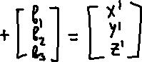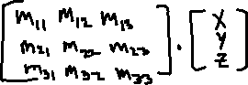

From this matrix multiplication we get a system of equations with unknown elements of the matrix M (mii) and vector b. Because the X-Rays image does not have Z’ coordinate, to recover unknown values we need to use coordinates of 4 fiducials per each X-Rays projection. Finally we obtain 8 equations with 8 unknown values per each projection (16 equations totally). Equations can be solved with standard methods to obtain M, b and N, c.

Reversed recovery of the bot’s position in a 3D animal-associated coordinate system can be done by solving the next system of equations:



Where Xb, Yb and Zb are desired coordinates of the bot in the animal-associated system.

Proposed method was realized using Python and tested on a cube-shaped model using the regular camera. Error of the “bot” position definition did not exceed 5 mm and can be reduced.

Shustov. Bionaut labs. 21/01/2023